Software Requirements Specification
for
CONNECT EASY using MERN Technology
Version 1.0 approved
Prepared by Harshit Gupta, Iffat Rizvi, Ishita Bharadwaj
KIET Group of Institutions
April 18, 2023
Table of Contents
Table of Contents ii
Revision History ii
1. Introduction 1
1.1 Purpose 1
1.2 Document Conventions 1
1.3 Intended Audience and Reading Suggestions 1
1.4 Product Scope 1
1.5 References 1
2. Overall Description 2
2.1 Product Perspective 2
2.2 Product Functions 2
2.3 User Classes and Characteristics 2
2.4 Operating Environment 2
2.5 Design and Implementation Constraints 2
2.6 User Documentation 2
2.7 Assumptions and Dependencies 3
3. External Interface Requirements 3
3.1 User Interfaces 3
3.2 Hardware Interfaces 3
3.3 Software Interfaces 3
3.4 Communications Interfaces 3
4. System Features 4
4.1 System Feature 1 4
4.2 System Feature 2 (and so on) 4
5. Other Nonfunctional Requirements 4
5.1 Performance Requirements 4
5.2 Safety Requirements 5
5.3 Security Requirements 5
5.4 Software Quality Attributes 5
5.5 Business Rules 5
6. Other Requirements 5
Appendix A: Glossary 5
Appendix B: Analysis Models 5
Appendix C: To Be Determined List 6

Revision History
Name | Date | Reason For Changes | Version

Introduction

Purpose
The purpose of this SRS document is to provide a detailed overview of our software products, its parameters and goals. It defines how this application is to facilitate the buying and selling of used products with the college hostel community, creating a convenient and efficient platform for students to trade items they no longer need. The chatbot feature is intended to promote interaction between junior and senior students, providing a channel for communication, information sharing, and assistance.

Document Conventions
Priorities for higher-level requirements are assumed to be inherited by detailed requirements, or whether every requirement statement is to have its own priority.

Intended Audience and Reading Suggestions
The project is being designed for the college students. The students face a lot of problems while they are staying in their hostels. Thus, we want to automate the entire hostel management so that they can enjoy staying at hostels and also provide an efficient way to buy and sell their used products. The major issue of interaction between junior and senior has also been resolved using the chatbot option in our application. This document also serves as a contract between the owner of the software and the developers where the owner can clearly see what and how the developers intend to do to make the software.

Product Scope
The goal is to design a robust software for the management of hostel. In the project, we automate the working of the hostels and the college students. This project addresses a real-world issue that the students are experiencing. Final-year students are anxious about their products because they are no longer helpful to them. Here, we offer a solution to their issue by establishing a connection between recently admitted students and college seniors. Avoiding scrapping of the items and assisting both seniors and juniors with this endeavour are the main goals. Additionally, the development of our website's chat system has allowed us to address the issue of interactions between majors and minors.
The Hostel Used Products Buy and Sell Platform will provide the following features:

User Registration and Authentication: Users, including junior and senior students, will be able to register and create accounts on the platform. Authentication mechanisms such as email verification or social media login will be implemented to ensure the security of user accounts.

Product Listings: Users will be able to create listings for the products they wish to sell, including details such as product name, description, price, and images. Listings can be searched, filtered, and sorted by various criteria such as category, price range, and location.

Messaging and Chatbot Interaction: Users will be able to send messages to each other for inquiries, negotiation, and communication regarding the listed products. Additionally, a chatbot feature will be implemented to facilitate interaction between junior and senior students, providing information on college events, academic resources, and general assistance.

User Profiles: Users will have profiles where they can view their own listings, messages, and chatbot interactions. Profiles can also include information such as user bio, profile picture, and contact details.

Notifications: Users will receive notifications for actions such as new messages, product inquiries, and chatbot responses.

Administration and Moderation: An admin panel will be implemented to manage user accounts, listings, and chatbot responses. Moderation features such as reporting and flagging of inappropriate content will also be implemented to ensure a safe and respectful environment.

References
- IEEE SRS Format Std 830-1998
- Software Engineering by Ian Sommerville

Overall Description

Product Perspective
The product will run as a website wherein when the concerned student opens the home page of the website, the students will be asked to sign up if it’s the first time he or she using the portal. If they have been using the site, they will be asked to login. Once they login, they will be able to see the three features of the website which includes buying or selling of the hostel products and a chatbot option.

We will create a well-integrated portal for the management of hostel and for the college students also. Our priority will be to increase the interaction between the all the college students. In our website, a student can add the used products along with its features. The needy students can go to the website and can buy that product or also have the option of add to card. Once the buying or selling of products is completed, the students can also give the feedback about the product. Another feature we are having in our website is ticket raiser, it is for all the hostellers to lodge/complaint regarding the hostel products like the maintenance of electrical or carpenter objects. Last but not the least, additionally, the development of our website's chat system has allowed us to address the issue of interactions between majors and minors.

Product Functions
I. It must be able to authenticate the login id and be able to create new login id for the students of college and for the staffs as well.
II. It must be able to notify the requests made by the students residing in hostels to the respective staff members of hostel.
III. It must be able to take the feedback from the students once the task is completed and also be able to take the feedback.
IV. It must be able to provide the smooth flow of interaction between the junior and senior using chat option and also create the group.

User Classes and Characteristics
User Classes:
1.Hostel students: By login the website, Hostel students can add or buy products from the website.
2.College students: By signing up, the students can interact with their junior or senior by the help of chatbot option.
3.Admin: The owner of the website who manages all the buying and selling profiles.

User Characteristics:
1.The students must have a technical knowledge of how to add the products on website.
2.The hostellers should know how to request or complaint regarding the hostel products using ticket raiser option.
3.The students should know how to create a group and provide authentication.

Operating Environment
Hardware Requirements: This may include details memory (RAM), storage (e.g., hard disk space), and any other relevant hardware components.

Software Requirement: This may include the operating system (e.g., Windows, macOS, Linux), web browsers (e.g., Chrome, Firefox, Safari), and any other software that is required to be installed or supported for the application to function properly.

Network Requirements: Describe the network environment needed for the system to operate effectively. This may include information on the type of network connection required (e.g., wired, Wi-Fi), bandwidth requirements, and any other network-related considerations.

Third-Party Services: Identify any third-party services or APIs (Application Programming Interfaces) that are required for the system to integrate with, such as payment gateways, chatbot platforms, or other external services. Specify any necessary configurations or dependencies related to these services.

Deployment Considerations: Provide information on how the system will be deployed in the operating environment, including details on hosting requirements, deployment architecture, and any other relevant considerations for deploying and maintaining the system.

Limitations and Constraints: Identify any limitations or constraints related to the operating environment that may impact the functionality or performance of the system. For example, if the system is limited to a specific operating system or hardware configuration, or if there are any legal or regulatory constraints that need to be considered.

Design and Implementation Constraints
The development of the system will be constrained by the availability of required software such as web servers, database and development tools. The availability of these tools will be governed by the KIET Group of Institutions. The hardware constraints include a smartphone or laptop to access the website and make the request.

Assumptions and Dependencies
The following list prevents the assumptions, dependencies or guidelines that are imposed upon implementation of System:
I. The product must have a user friendly interface that is simple enough for all types of users to understand.
II. Response time should not be longer than 5 seconds.
III. A general knowledge of basic computer skills and internet is required to use the product.

External Interface Requirements

User Interfaces
The goal is to design the software used for the proper management of hostels and automate the process of buying and selling of used products between the students. The user types are listed followed
- Students
- Admin
- Hostel Staff

Our goal is to develop a software that should be easy to use for all types of users. Thus while designing the software one can assume that each user type has the following characteristics:
- The user is a computer-literate and has little or no difficulty in using the software keeping in mind the software is user friendly.
- In order to use software a user must be aware of the internal working and expected to know how things work.
- All the guidelines about the use of software will be informed to the user once the user signs up on the software or web page.

Hardware Interfaces
- Computer: A computer will be required to open the website and use the software.
- Smartphone: A smartphone can also be required in case there is no availability of computer.
- Internet: A good internet connection is requires to access the website.

Software Interfaces
- A SQL Database Server will be required to store and retrieve data.
- A web browser will be required to open the website.

Communications Interfaces
I.User-Friendly Interface: The communications interface should be designed to be user-friendly and easy to navigate. It should allow users to quickly and easily browse through listings of hostels, buy and sell products, and communicate with other users. Clear and intuitive buttons, icons, and menus can enhance the user experience.

II. Search and Filter Options: Users should be able to search and filter listings based on various criteria, such as location, price range, and product category. This can help users find relevant listings quickly and efficiently.

II.Feedback and Rating System: A feedback and rating system can help users evaluate the reliability and trustworthiness of other users. Users should be able to leave reviews and ratings for hostels, products, and chatbot interactions, which can help build a community of trust and credibility.

IV.Multi-Platform Accessibility: The communications interface should be designed to be accessible on multiple platforms, such as web browsers, mobile devices, and possibly through a dedicated app. This can ensure that users can access the platform and interact with others conveniently and efficiently from various devices.

V.Customization Options: Providing customization options, such as user profiles, profile pictures, and notification settings, can allow users to personalize their experience on the platform and make it more engaging and enjoyable.

VI.Help and Support Features: The communications interface should provide help and support features, such as a FAQ section, contact information for customer support, and online help documentation, to assist users in navigating the platform and resolving any issues they may encounter.

VII.Social Media Integration: Integrating social media features, such as sharing listings or products on social media platforms, can help users promote their listings and products and increase visibility.

In conclusion, the communications interfaces for a hostel buy and sell platform, as well as products of used products, and chatbot options for customer interaction should prioritize user-friendliness, security, customization, and support features to enhance the overall user experience and foster a vibrant and trusted community within the platform.

System Features

System Feature 1

Authentication:

Authentication is the process of identifying users that request to a system, network, or device. Access control often determines user identity according to credentials like username and password. Other authentication technologies like biometrics and authentication apps are also used to authenticate user identity.

System Feature 2

Customer Module

Customer will be able to login to an account on our website and do seamless searching.

System Feature 3

Seller Module

Different students would be able to create an account on our website and add the details of the products they are selling.

System Feature 4

Google Form

This feature will help the hosteler to register their complaints regarding hostel facility to be done in a shorter period of time.

System Feature 5

Chat Option

The student can interact with seniors/juniors using search options in the respective development field.

Other Nonfunctional Requirements

Performance Requirements
Specify the expected response time for the system, such as loading time for web pages or query response time for the chatbot. For example, "The system shall load web pages within 2 seconds, and the chatbot shall provide responses within 1 second."

Safety Requirements
Define how the system should handle an increasing number of users or products over time. For example, "The system should be able to handle up to 1000 concurrent users and support up to 10,000 products without significant degradation in performance."

Security Requirements
Outline the security measures to be implemented to protect user data, such as authentication, encryption, and data privacy. For example, "User passwords shall be stored securely using industry-standard encryption techniques" or "The system shall comply with GDPR regulations for data privacy."

Software Quality Attributes
Specify the expected uptime and availability of the system, including backup and recovery procedures. For example, "The system shall have a minimum uptime of 99% and regular automated backups shall be performed every 24 hours."

Business Rules
The system shall have a responsive and user-friendly interface accessible from desktop and mobile devices, complying with WCAG 2.0 accessibility standards.

Other Requirements
The system shall not infringe on any copyright or intellectual property rights of third parties or "The system shall comply with local laws and regulations related to online marketplace and e-commerce."
The system shall receive regular software updates and bug fixes for a period of 2 years from the project delivery date" or "Technical support shall be provided during business hours via email and chat.
Appendix A: Glossary
Mongo DB:

MongoDB is an open-source document-oriented database that is designed to store a large scale of data and also allows you to work with that data very efficiently. It is categorized under the NoSQL (Not only SQL) database because the storage and retrieval of data in the MongoDB are not in the form of tables.

Node.js:

Node.js (Node) is an open source development platform for executing JavaScript code serverside. Node is useful for developing applications that require a persistent connection from the browser to the server and is often used for real-time applications such as chat, news feeds and web push notifications.

Express-js
Express is a node js web application framework that provides broad features for building web and mobile applications. It is used to build a single page, multipage, and hybrid web application. It's a layer built on the top of the Node js that helps manage servers and routes.
Material UI
It is used for styling the frontend.

Appendix B: Analysis Models
ER DIAGRAM
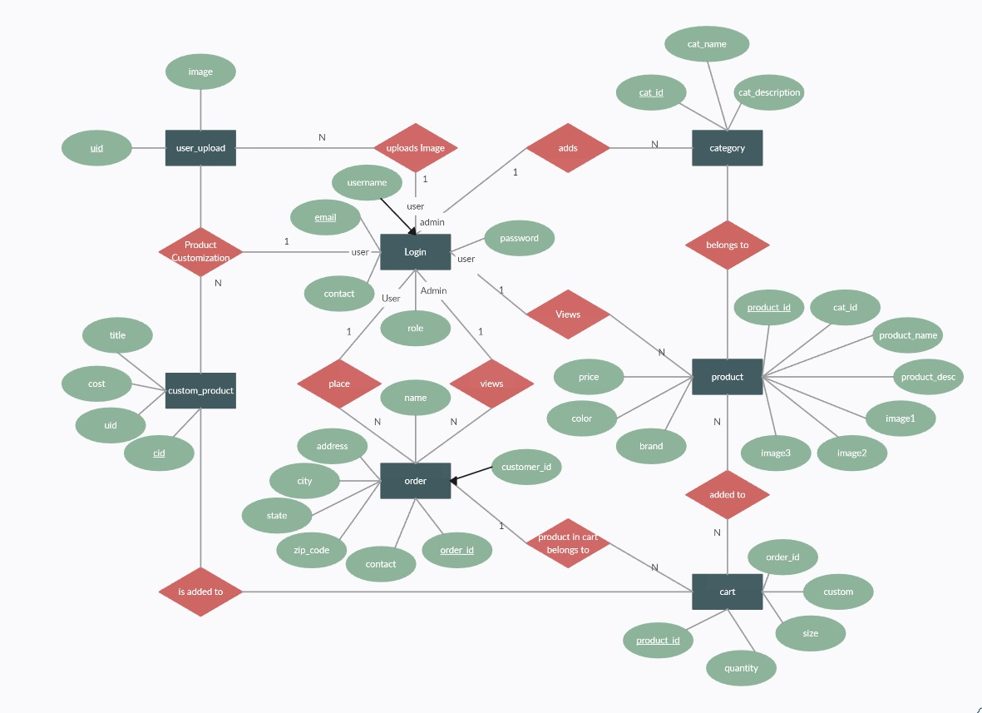

WORKFLOW DIAGRAM

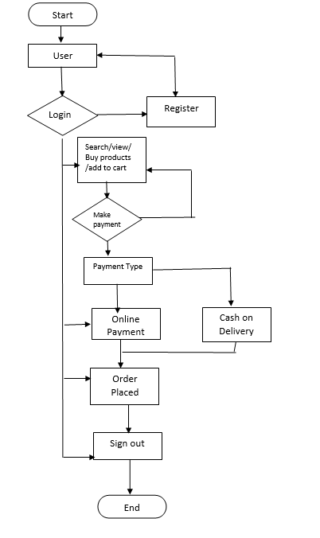

USE CASE DIAGRAM
